**Ideation Phase**

**Define the Problem Statements**

|  |  |
| --- | --- |
| Date | 01 October 2022 |
| Team ID | PNT2022TMID47483 |
| Project Name | Gas leakage monitoring and alerting system for industries |
| Maximum Marks | 2 Marks |

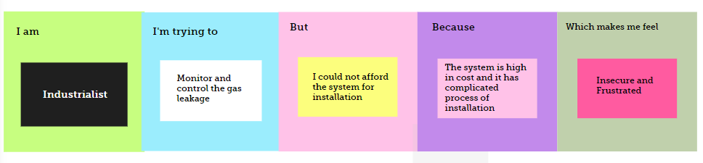

|  |  |  |  |  |  |
| --- | --- | --- | --- | --- | --- |
| **Problem Statement (PS)** | **I am (Customer)** | **I am trying to** | **But** | **Because** | **Which makes me feel** |
| PS-1 | Industrialist | Monitor gas leakage | I don’t know about the monitoring system and the process to monitor it | The system is high in cost and not affordable and it also causes disaster | Insecure |
| PS-2 | Industrialist | Control the gas leakage | The installation process of the system is too complicated | The sensor required for the process is unpredictable and also it might not go off in a proper position | Frustrated |